Process | Action
Provider Administrator | The Step by Step Instructions for New Mexico Provider Administrators agencies will outline the process on how to discharge an individual from the Therap system.
How to Discharge an Individual | Only people with designated user privileges with the ‘Individual Admit/Discharge’ role or ‘Individual Administrative’ role will be able to discharge people from the system. Users with these roles will find the Discharge button at the bottom of the Individual Data Form (IDF) page.  NOTE: Please do not discharge a deceased person, instead mark person as deceased.
- To begin, ensure the ‘Dashboard’ page is displayed.
- Click on the 'Individual' tab.
- Under the ‘Care’ section, click on the ‘Search’ link next to the Individual Data area.
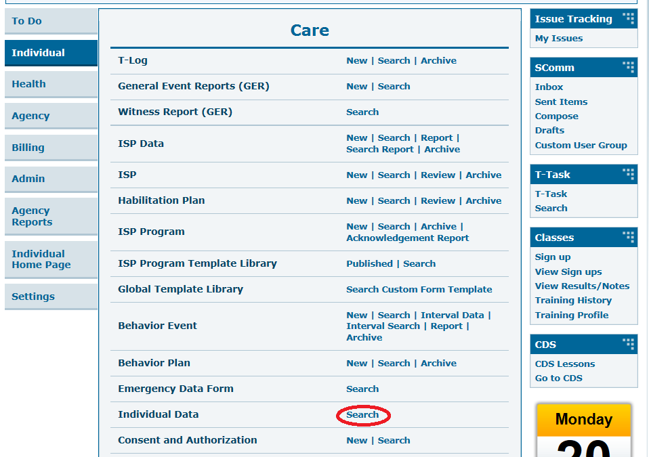
- You will be directed to the Individual Search page. Select a Program and enter the Individual's name. You may include other search parameters to narrow down your search results. Once done, click on the 'Search' button to view the search results.
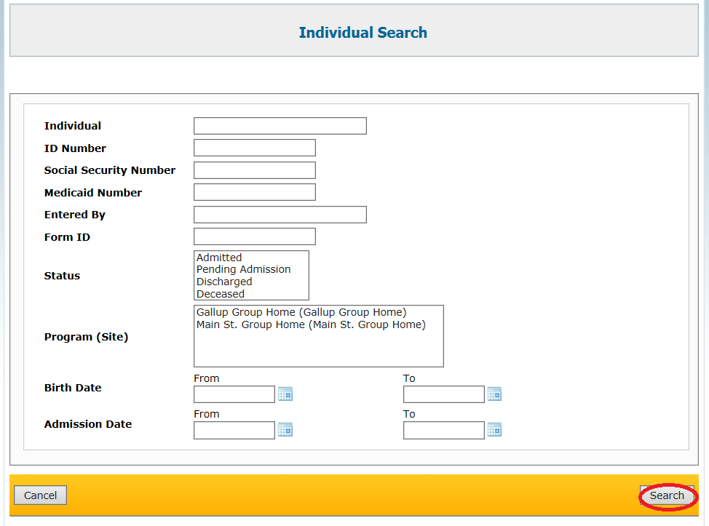
- On the Individual Search page select and click on the appropriate Individual to discharge.
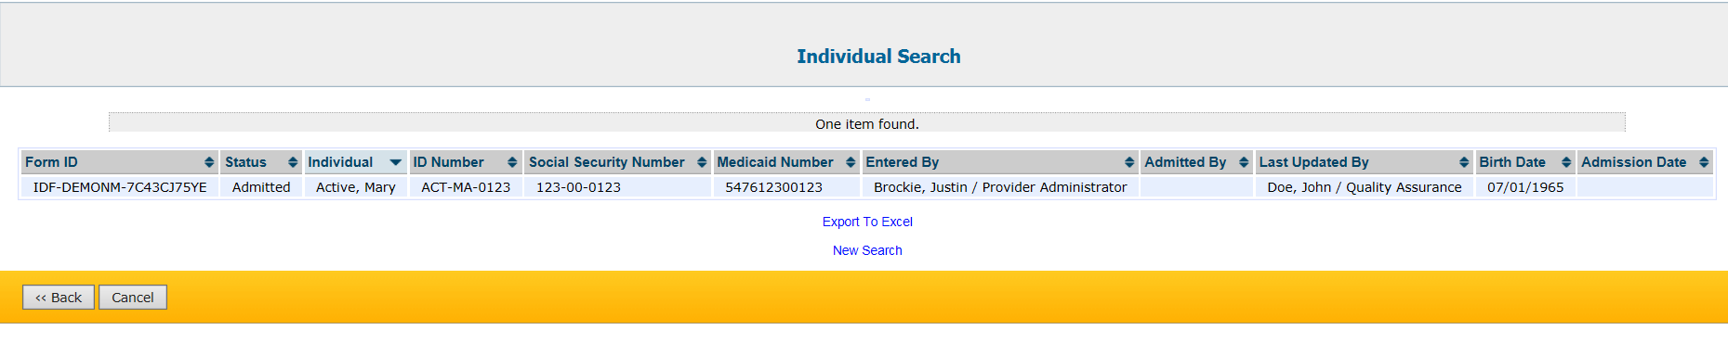
- This will open the Individual Data page of the Individual you have selected. Scroll down to the bottom of the page and click on the 'Discharge' button to discharge the Individual from the system.
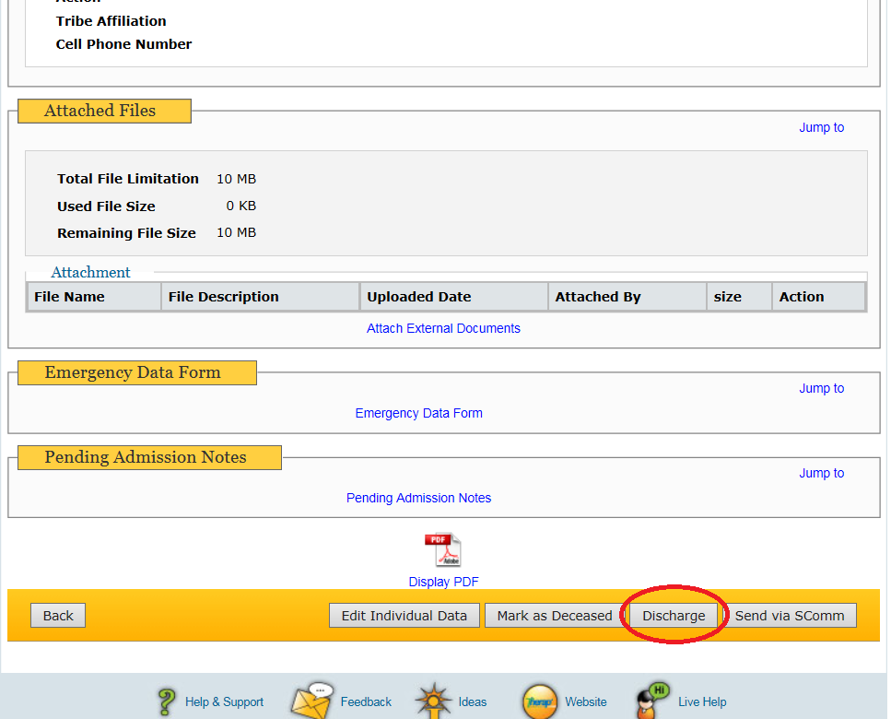
- This will open the Discharge Individual page. Enter necessary information including the Date of Discharge and click on the ‘Done’ button to complete discharging the Individual.

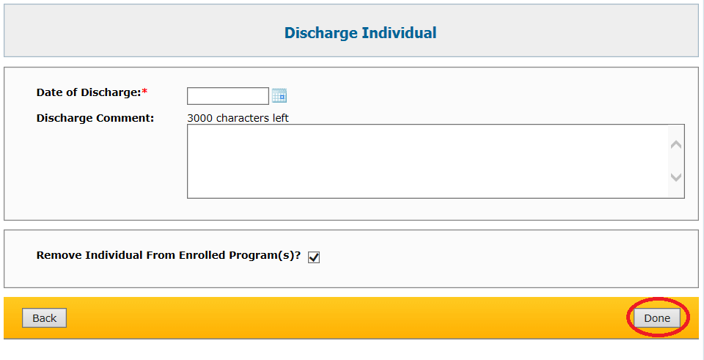

- A message will appear to confirm that the Individual was successfully discharged from the system.
