Process | Action
Provider Administrator | The Step by Step Instructions for New Mexico Provider Administrators agencies will outline the process on how to mark an individual as deceased in the Therap system.
How to Mark an Individual as Deceased | Only people with designated user privileges with the ‘Individual Admit/Discharge’ role or ‘Individual Administrative’ role are able to mark an individual as Deceased. Users with these roles will find the Mark as Deceased button at the bottom of the Individual Data Form (IDF) page.
- To begin, ensure the ‘Dashboard’ page is displayed.
- Click on the 'Individual' tab.
- Under the ‘Care’ section, click on the ‘Search’ link next to the Individual Data area.
- You will be directed to the Individual Search page. Select a Program and enter the Individual's name. You may include other search parameters to narrow down your search results. Once done, click on the 'Search' button to view the search results.
- On the Individual Search page select and click on the appropriate Individual to discharge.
- This will open the Individual Data page of the Individual you have selected. Scroll down to the bottom of the page and click on the 'Mark as Deceased' button to change the status of the Individual as deceased.
- This will open the Mark Individual as Deceased page. Enter the Date of Death. Click on the ‘Done’ button to complete.

- A message will appear to ensure that the Individual was marked as Deceased.
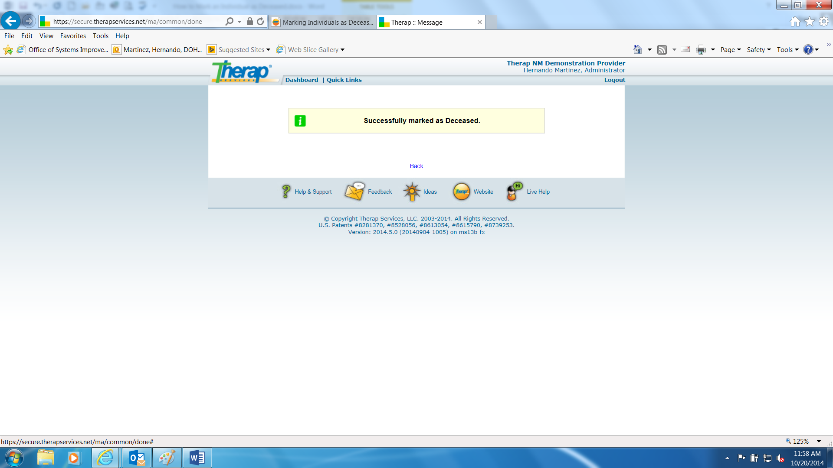

- Click on the Back link to return to the Individual Data page. Note that on the Individual Data page of the Individual, the 'Status' of the Individual will show as 'Deceased'. NOTE: If a 'Deceased' Individual already has Death Date, they cannot be made blank while editing Individual Data.

