**Guidance ECRS 2013-1**

**This is the first in a series of communication regarding guidance on requirements for data entry into the Electronic Case Record System (Therap).  Please share this guidance with your organization’s Therap users in order for them to know what is being required effective Monday 9/30/2013.  It is extremely important to be consistent in our data entry so that when monitoring or reporting occurs within the system, that the information is reliable and valid.**

This guidance – (ECRS 2013-1) is in regard to the Medical Appointment record portion of the electronic case record system (Therap).  As a State, we are required to track and report on the occurrence of several medical items such as the Comprehensive Physical, Dental Examination by a Dentist, etc.  To assure that entry into the electronic case record is consistent and will provide the necessary information for reporting purposes, please do the following:

***Comprehensive Physical Examinations***

For Appointment Type* - Please select “Primary Care” from the look up table.

Reason for Appointment - Please select “Annual Physical” in the drop down box (this option should only be selected when the comprehensive physical examination is completed as scheduled – i.e. every 1, 2 or 3 years).

For all other “Primary Care” appointments – Please select “Follow-up Appointment”, “Regularly Scheduled”, etc. ,whichever is appropriate, as the reason for the appointment.

Enter the follow-up or return to office (RTO) information in the comment section at the bottom of the screen.

All other information in the medical appointment record should be completed as you have been doing.

Scan and attach the Physical Examination form and/or MAIR as an external document in Section 3 of the medical appointment record.

***Annual Dental Examinations by the Dentist***

For Appointment Type* - Please select “Dentist” from the look up table (Select Primary Care if the patient is edentulous or has no teeth and is not being seen by a Dentist).

Reason for Appointment – Please select “Annual Dental Screening” from the drop down box (this option should only be selected whenever a dental examination or oral cancer screening is completed by the Dentist or PCP).

For all other “Dentist” appointments – Please select “Dental Cleaning”, “Follow Up Appointment”, or “Regularly Scheduled”, whichever is appropriate, as the reason for the appointment.

Enter the follow-up or return to office (RTO) information in the comment section at the bottom of the screen.

All other information in the medical appointment record should be completed as you have been doing.

Scan and attach the Dental Examination and/or DAIR as an external document in Section 3 of the medical appointment record.

***Colonoscopy***

For Appointment Type* - Please select “Primary Care or Gastroenterology” from the look up table.

Reason for Appointment – Please select “Colonoscopy” from the drop down box.

Enter the follow-up or return to office (RTO) information in the comment section at the bottom of the screen.

All other information in the medical appointment record should be completed as you have been doing.

Scan and attach the colonoscopy report and/or MAIR as an external document in Section 3 of the medical appointment record.

***DEXA Scan***

For Appointment Type* - Please select “OB/GYN, Primary Care, or Rheumotology” from the look up table.

Reason for Appointment – Please select “DEXA Scan” from the drop down box.

Enter the follow-up or return to office (RTO) information in the comment section at the bottom of the screen.

All other information in the medical appointment record should be completed as you have been doing.

Scan and attach the DEXA Scan report and/or MAIR as an external document in Section 3 of the medical appointment record.

***Eye Examinations***

For Appointment Type* - Please select “Ophthalmology/Optometry” from the look up table.

Reason for Appointment – Please select “Eye Exam” from the drop down box.

Enter the follow-up or return to office (RTO) information in the comment section at the bottom of the screen.

All other information in the medical appointment record should be completed as you have been doing.

Scan and attach the MAIR as an external document in Section 3 of the medical appointment record.

***OB/GYN Examinations/mammograms***

For Appointment Type* - Please select “Obstetrics & Gynecology” or “Radiology”, whichever is appropriate, from the look up table.

Reason for Appointment – Please select “Mammogram” or “OB/GYN Exam & Pap”, whichever is appropriate, from the drop down box.

Enter the follow-up or return to office (RTO) information in the comment section at the bottom of the screen.

All other information in the medical appointment record should be completed as you have been doing.

Scan and attach the Mammogram report and/or MAIR as an external document in Section 3 of the medical appointment record.

***PSA Screenings (Primarily for men over 50 years of age)***

For Appointment Type* - Please select “Primary Care” or “Urology”, whichever is appropriate, from the look up table.

Reason for Appointment – Please select “PSA Screening” from the drop down box.

For all other “Urology” appointments – Please select “Follow Up Appointment” or “Regularly Scheduled” as the Reason for Appointment

Enter the follow-up or return to office (RTO) information in the comment section at the bottom of the screen.

All other information in the medical appointment record should be completed as you have been doing.

Scan and attach the PSA screening report and/or MAIR as an external document in section 3 of the medical appointment record.

Adherence to the above guidance will insure that reports being generated from this information will be dependable and valid as to the medical services being provided to the individuals that we all serve.

Following is the screen shot from Therap with the two specific fields being referenced above shown.

Should you have any questions, please let me know.

Bob

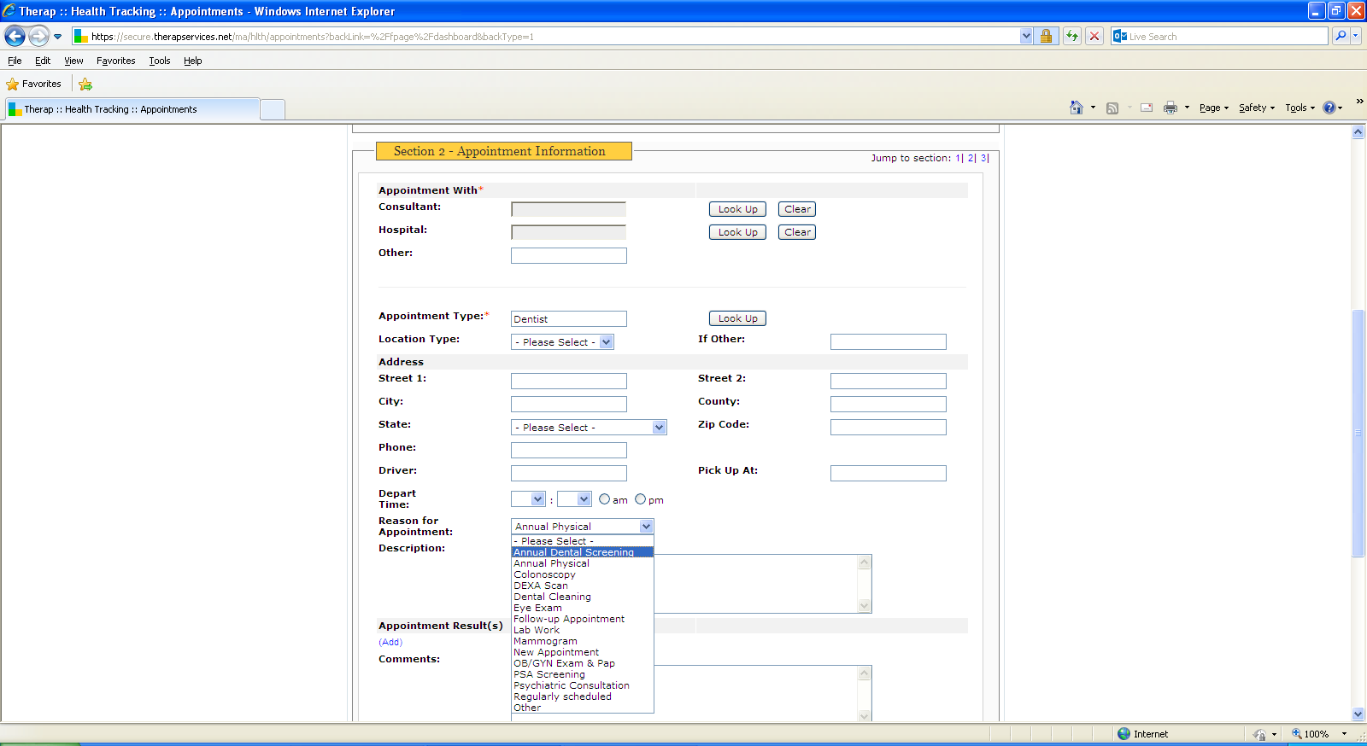

Robert T. Goodhart

Quality Assurance Administrator

DDDS - Office of Quality Improvement

2540 Wrangle Hill Road, Suite 200

Bear, DE  19701

(302) 836-2176 Phone New Castle

(302) 741-9343 Phone Kent/Sussex

(302) 836-2647 Fax

"Think of how you can assist on a problem, not who to blame."   Author Unknown