**Guidance ECRS 2013-2**

**Following are changes that were recently implemented in Therap that does and does not have an impact on the work that you do in RN services. Let me explain.**

The First change is that when you login to Therap, your user ID is no longer saved.  This change was a security enhancement implemented by Therap.  Therefore each time you login you will need to re-enter your User ID, as well as password.

Secondly, following is the guidance issued by Therap as to the change in the eCHAT section of the system.  As you will see there is reference to an MAAT and ARST that should be completed before your assessment.  This is what we have been able to determine.

1. MAAT is a tool that is specific to the State of New Mexico.  Therefore, even though it states that it must be completed, this does not impact your work and you can ignore the MAAT request.
2. ARST is the Aspiration Risk Screening Tool.   You will continue to complete the current Aspiration/Choking Risk Assessment and attach in the safeguards section of the ELP.
3. The Reason for Assessment in eCHAT should be selected from the drop down box options.  Should you not find the proper reason (option), please discuss with your supervisor for clarification.  Should a specific reason need to be added into the system selection (drop down options) this request should be forwarded to [bob.goodhart@state.de.us](mailto:bob.goodhart@state.de.us) through your agency’s designee to request having it added as an option in the future.
4. Date of Assessment should be the actual date of your assessment and not the date of the ELP meeting as was used in the past when completing the ELP RN Assessment.
5. The remaining display shows the process for linking Care Plans to the eCHAT.  Further guidance on this process will be issued in the future. Continue to attach the health supports in the safeguards section of the ELP as was outlined in the email dated 8/2/13 from the ELP Oversight Committee.

**Comprehensive Health Assessment Tool (e-CHAT)**

[[Back to Top](http://support.therapservices.net/display/support/Release+Notes+for+Therap+2013.2#ReleaseNotesforTherap2013.2-top)]

* Options to enter Reason for Assessment and Date of Assessment have been added to the [**Comprehensive Health Assessment Tool (eCHAT)**](http://support.therapservices.net/display/documentation/Create+new+eCHAT). Users will be able to select the Reason for Assessment from the options that are available in the drop-down menu. The options in the drop-down menu includes 'Annual ISP', 'New Admission/Agency Transfer', 'Change of Condition', 'Hospital Discharge' and 'Hospital Discharge for Aspiration Pneumonia'. When creating an e-CHAT, this option allows users to enter the reason for the assessment to be made and also to record the date when the assessment was conducted.   
    
  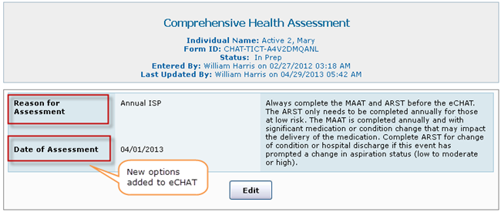
* An option to link Care Plans has been added to the [**Summary Report**](http://support.therapservices.net/display/documentation/Summary+Reports) that is generated for the Comprehensive Health Assessment Tool. By clicking on the Link Care Plan link, users will be able to link an approved Care Plan which is appropriate for a certain section of the **Summary Report**.   
    
  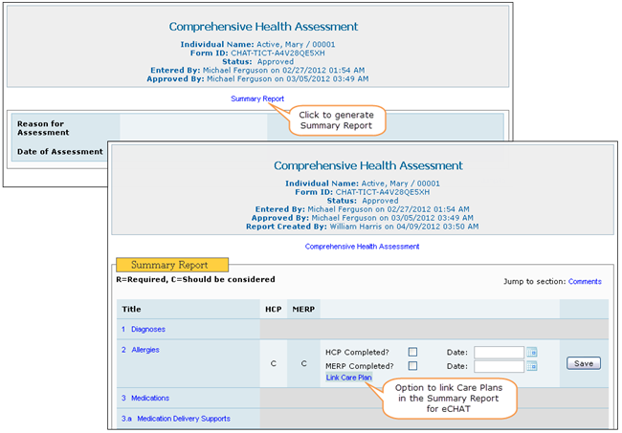
* **Comments** area has been added in each section in the Comprehensive Health Assessment Tool (eCHAT) along with other questions. This will allow users to add necessary comments for each of the sections in the eCHAT.   
    
  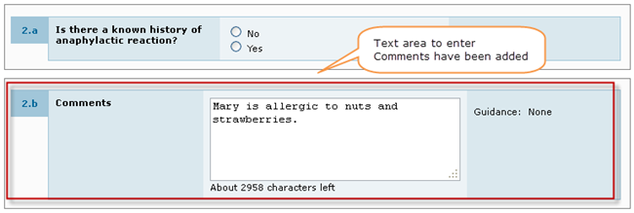

**ADDITIONAL QUESTIONS**

Q - Can sub-headings be added under health that could include the following: Physical Exam, Dental, Nutritional Evaluation, Psychiatry, and Gynecology that could include pap smears and mammograms?

A – At the current time, there is the option to utilize a drop down selection for the type of appointment that may or may not capture this information at this time.  What our goal will be is to provide guidance as to when or which drop down item should be selected at the time of creating the medical appointment record.  From there (once we have consistency in the record entry) is to make sure that there is a reporting function that would be able to generate the type of specific information that one needs access to whether it would be the RN, MD, or house staff to assure that we have all of the necessary information available for proper use.

Q – Can the MAIR’s or reports from the MD be available to view while completing the eCHAT?

A – At this time, this is not an option, but is something that can be considered as part of the system as we move into the future.

I’ll be happy to answer any questions, but first ask your supervisor to see if they can assist you and if not, please have your question forwarded to me so that I can research and respond.  In order to get you the best possible answer, as you have a situation occur that you need assistance with REMEMBER – the more specifics you can provide such as the module and or field you are working with will aid in getting you a reliable response.  This can be done by taking “Screen Shots” of where you are in the system at the time that your situation occurs (CTRL + PrtScn then open a blank WORD Document and paste or past directly into the body of your email).