Referral Workflow – For Users in Nebraska

The Referral module can be used by the State of Nebraska/Service Coordinator to refer an individual for services to other Provider Agencies. At the end of a successful Referral process, the individual referred is admitted by the Provider Agency.

The following flow diagram explains the entire Referral process:
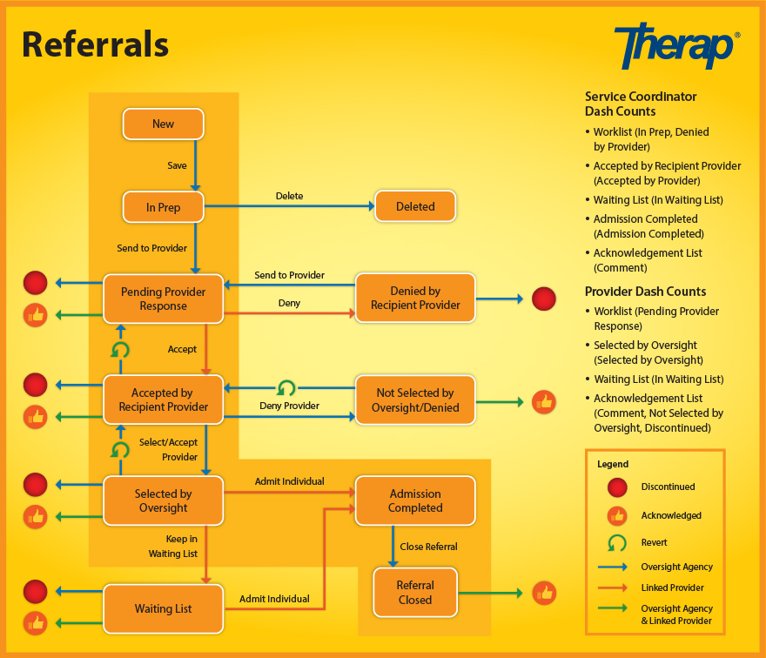

At the beginning of the Referral process the State of Nebraska/Service Coordinator selects an individual from their List. Once the particular individual has been selected, the user enters the required information on the Referral form and may either choose to send the Referral Packet to a particular Provider or to all the Providers from a particular region or to all Linked Providers in the state.
When a Provider Agency receives a Referral Packet, the Provider Agency may either accept or deny the Referral or enter their comments and update the form. The Referral form is then sent back to the State of Nebraska/Service Coordinator.
If the Referral is accepted and sent back to the State of Nebraska/Service Coordinator, the State of Nebraska/Service Coordinator may then accept or deny the Referral as well as update or revert the Referral. The Referral is again sent back to the Provider Agency with further details.
The Provider Agency may then admit the individual or keep the individual in their Waiting List. At the last step of the process, the Referral is sent back to the Provider Agency by the State of Nebraska/Service Coordinator. Once the individual has been admitted by the Provider Agency, the State of Nebraska/Service Coordinator may close the Referral.
For more information on the Referral module, you may refer to the following user guides:
- Referral Oversight Agency (the State Of Nebraska)
- Referral Provider End (Providers Of Nebraska)

