Referral for Services – FAQ April 2012

The following Flow Diagram explains the entire Referral process.
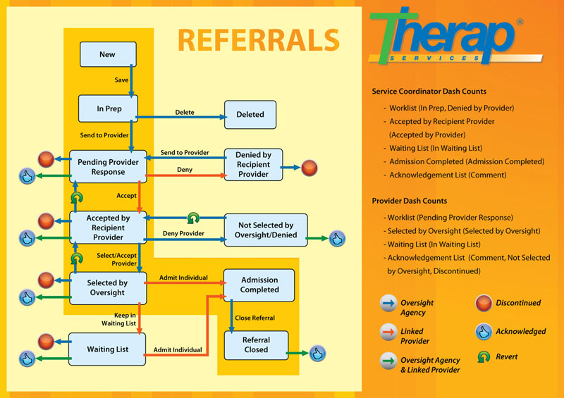

Documentation

Referral - Oversight Agency (State of North Dakota) (link to website flow)

- Choose the notification level: defined
  - HIGH – immediate need for services. The client is about to lose their current placement or services or are not enrolled in services but are in need of immediate support (e.g. homeless, facing jail). Services are typically needed within the next 30 days. Response is needed from the provider within 2 working days if they are able to serve this person. (providers-please be looking daily for HIGH referrals)

  - MEDIUM – services are anticipated to start in a few months up to a year. They may be in services now, but want another placement option. This could be a transition from school to start services or an alternative placement is being sought. They may be receiving services now, but want to move to another location.

  - LOW – this selection is for those that may be 1 year or more out. They may have services but their preference is to move to another service, they may be living with their parents and are anticipating a move in the future to a place that they feel would better suit their needs.

Referral - Provider End (North Dakota Agency Providers) (link to website flow)
THE HOW-TO’S FOR REFERRALS – DOWN TO THE NITTY GRITTY!
Referrals for all services (other than Infant Development, Intervention Coordination for the Autism waiver, Family Subsidy, and self-directed services) must be completed utilizing the Referral for Services in Therap. The referral for services will be utilized for:
- New individuals who are being referred to DD licensed providers for the first time
- Individuals who are seeking services from another DD licensed service provider
- Individuals who are looking for more services*
- Statewide referrals

The typical Referral process steps are:
- DDPM creates a referral packet (s) on behalf of the client. If you have additional information that you have scanned in and need to attach to this referral packet that is not included on the list of items to attach, you can click on the section to “attach other file”. To do this, here are the steps:
  - Click on the word “attach”
  - Find the file you want to attach from your computer and click on this file (in PDF format please so that it is NOT EDITABLE by those who can view this)
  - Click “open”
  - Name the file
  - Click “save” in Therap
- DDPM sends the referral to the provider (s) as requested by the client and selects the appropriate notification level (High, Medium or low).
- If the provider requests more information by placing comments section in the referral packet, you can go into that specific packet and attach the other supporting documentation for the referral packet. If more than one provider asks for additional information, you will have to go into each individual referral packet and attach. Please keep your scanned documents in an area that you remember so that it’s easily found to attach future requests.
- Provider accepts or denies the referral
  - For Highs, the provider must respond within 2 working days if they accept or deny.
  - For low and medium notifications, the provider must respond within 30 days
- If the provider accepts, the DDPM will confirm with the client that they want that provider, and will then accept the provider (go to pre-placement process). If the client does not want that provider, they can deny them at any time in the process and the DDPM can discontinue the referral.
- If the provider denies the referral with no intentions of serving this person, the DDPM can go in and discontinue the referral, which will close access to the information contained in the packet.
- If they are accepted by the provider and the DDPM accepts on behalf of the client, the DDPM needs to contact the State DD Therap help desk to link the oversight ID with the provider.
- Once you have received confirmation that they have been linked, the DDPM can close the referral.

WAITING LIST:
A client may be placed on a waiting list by the provider by the following process:
Provider accepts; DDPM accepts for the client and then the provider has the option to place them on a waiting list or admit them. They will need to put in the anticipated date of admission. A Client may be on more than one waiting list until placement has happened and they have moved in! DO NOT contact the state office to link until an admission date is pending and you have confirmed that they will be coming off the waiting list so that we can link the correct provider!
Pre-placement Process
Placement planning information will be shared with all interested parties so that teams can move forward. This is to be used when there is an available opening and a person is being actively considered (not when accepted for waiting list, etc.). Final decision, as always, will be made by teams and legal decision makers. This format will compel teams to process risks and strategies that need to be operational as part of an interim plan and as a first step for offering enough information for informed choice, whether there is only one choice or multiple providers are interested in serving an individual. Communication with all interested parties is also formalized.

Inter-regional and institutional placements
- Referral is initiated by DDPM (sending region) to providers through Therap system. For those consumers residing at NDDC or NDSH who are not currently assigned in the DDPM system, the “home” region would be responsible to open case – including determination of eligibility and initiating referral.
- Referrals are considered by selected providers in Therap (either by specified providers or for all statewide).
- When the sending region is contacted by a provider regarding interest in serving the referred individual, the assigned DDPM will contact the receiving region’s DDPA to consider assignment of a local DDPM to be included in the planning process. Agreement that the individual can be adequately served in the proposed environment amongst team members from sending region, receiving region, legal decision maker, and provider is needed.
- Every effort should be made that receiving region and provider have face to face visit with the individual; preferably that the individual will visit the prospective home setting, meet potential housemates, etc., prior to the planning meeting or is scheduled as appropriate, depending on client needs.
- If/when multiple providers have expressed interest in providing services to a client, the legal decision maker/consumer will be given access to enough information to make an informed choice. The number of visits and interviews during this process may vary depending on the complexity of services requested and the number of providers they have to choose from.
- Interim planning meetings will be coordinated (possibly as part of visit) and need to include current provider, sending and receiving DDPM, DD Division, individual – as appropriate, and legal decision maker). The meeting agenda will include:
  - Review of 24/7 Risk assessment - completed and updated specifically to the proposed environment.
  - Key areas of support – for personal care, adaptive skills, critical health and safety risks (risks that are likely to occur or leading to involvement with legal, medical or other support systems) are incorporated into an Interim Plan.
  - To be more specific, discussion should include:
    - Options and timing for Day Supports/Day program/ School ;
    - Transportation – both generic and agency to be researched, explained and understood;
    - Housing (affordability – room & board costs, accessibility, etc.)
    - Benefits discussed – including clear assignment of responsibility for notifying and completion of applications needed (MA, SSI, SNAP, Housing Assistance)
    - Coordination of generic services and who is responsible (medical provider, dental provider, specialists, psychiatry, behavioral supports, etc.). Follow up communication may need to occur and appropriate releases/authorizations to share information will be completed.
    - Level of staff resources in the proposed environment are discussed between DDPM/PA’s in the sending and receiving regions prior to the meeting. Teams should be made aware of staffing available as part of planning meetings. Should current available resources not be adequate to meet needs, the provider will need to complete and submit (to sending DDPM) the enhancement form. Potential ISLA placements will require completion of the ISLA checklist.
    - An individual’s daily schedule (weekday and weekend) should also be developed as part of the interim plan, realizing that some flexibility will be required.
    - For those leaving an institutional placement (ICF – ID or NDSH for XX months or more) and moving to an HCBS –DDD waiver qualifying setting, MFP resources need to be considered. Jake Reuter may be contacted for assistance or clarification of eligibility and resources.
- The format of the Admission OSP Plan is not specifically defined but must be easily understood. Restrictive support plans (behavior plans, etc.) will need to be reviewed and approved as per policy prior to move and implementation. Staff training will include reviewing this plan prior to working a shift. An electronic copy of the plan will be completed in Therap and distributed to team members (via Therap or paper copy for those not on that system).
- The Admission OSP plan will be replaced within 30 days by the 30-day comprehensive OSP.
Additional information to support the referral processes:
Once a provider has reviewed the referral information and responds by accepting the referral, the DD Program Manager will inform the individual so the individual can determine whether they wish to accept the provider and enroll in their services. If the individual accepts that provider referral, the DDPM will select “accept”. A client may want to wait before they make their decision, so the DDPM can wait for all to respond. When the client makes their choice, the DDPM will go into that referral and select “Accept” on behalf of the client. Once accepted into a provider, the provider will have a count show up on their dashboard that states “Pending Admission (#)”. The provider can open the referral and start the admission process or put the client on the waiting list along with the anticipated admission date**.

Before the DDPM can close the referral and begin the admission process with the provider, the DDPM will need to email the State Therap help desk noting this in the subject line so that they know to link the Oversight ID from the State Therap Record to the Provider Record as soon as they can. This will allow the OSP, RMAP etc. to flow back and forth between the provider and the DDPM.

Providers should NOT complete an IDF on the provider side. The IDF will be auto populated from the State side once the provider has accepted the referral, the client accepts the provider and the DDPM then selects “accept” for that referral.

If a provider has already created an IDF on the provider side, the DDPM may not be able to complete the typical referral process. This is true even if a provider created an IDF for an individual who was served in the distant past and has terminated services with that provider. Since an IDF already exists for that individual on the provider side, the provider will not show up on the list of providers to be chosen.

If the provider does not show up on the drop down list of providers to be selected when you are trying to send a referral, either the provider has an existing referral out there that needs to be closed or an IDF already exists. If closing the referral does not solve the problem then the DDPM will need to contact the State DD Therap help desk to check the status of the Oversight ID.
Denied by Recipient Provider:
If the provider hits the “Deny” button with no intention of providing services to the client or there is no future anticipated date of admission, the DDPM can go into this referral and discontinue it so this closes the referral and does not allow the provider to access the documents that were attached to this referral.

Paper referral process – If you have sent out a paper referral in the past, the DDPM can create a “mock” or dummy referral in Therap for that person who chose one of the providers to receive services from. To do this, find the person on your caseload and start a referral to that provider. You do not need to attach anything, unless there are new items that you would like this provider to have. Send to provider. The provider then accepts the referral and we can go on with the process listed above to link them and then close the referral. The reason this process is important is that it starts the IDF (Individual Data Form) on the provider side.
WAITING LIST?
**please note that if a provider feels that they can serve a client but do not have any openings at this time, they may accept the referral and put a comment in the section telling the DDPM this information and then include the anticipated admission date at the top of the referral. The DDPM may accept that referral on behalf of the client knowing that they will be put on a waiting list and once the DDPM hits the accept button, the provider has the ability to then put them on the waiting list and keep for tracking purposes for both the provider and the DDPM.

Referral (For users in North Dakota) – updated 4/15/2012
- Users are now able to send additional Referral to a Provider even if the Individual is already receiving service from that Provider. However, any 'in progress' Referral must be closed before sending a new Referral.
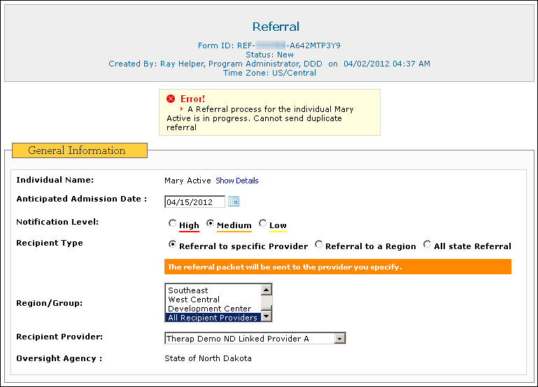
- If an Individual has existing Individual Data Forms in the Child Provider(s), then a list containing Provider Names and Referred Individual Status will be displayed before a new Referral can be sent.
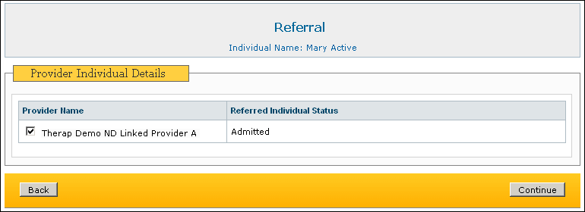
- Referrals with Recipient Types Referral to a Region and All state Referral can now be saved as Draft.

REMINDER FOR ALL-STATE REFERRALS

When a statewide referral is selected, every provider will get a copy of the referral. The referral is not limited to a particular service when sending a referral because we did not want to limit the possibilities. Sometimes providers who typically don’t provide a particular service may be willing to do so or a provider may come up with alternative service/supports that are suitable for the individual. The DDPM is encouraged to describe the individual’s situation and the person or their legal decision maker’s preferences and team recommendations in detail in the Referral comments box which will give the providers an idea of what supports the individual wants or needs.

If a person or their legal decision maker only want to select a certain provider(s) to send the referral, that can be done as well. The individual/legal decision maker will always have the option to select the service/supports and the provider they want to receive services from. Just because a provider has accepted the person doesn’t mean that the individual/legal decision maker has to accept the services or accept the provider.

The regional DDPA of the sending region should be notified of any referrals that are sent out of region and the RDDPAs in the receiving regions should also be notified that the referral has come to their region. If a statewide referral is sent then all DDRPAs will be notified (please see the “Regional Dashboard for Referral” section to follow).

For referrals that go out to the whole state and to all providers, the Developmental Center will receive these referrals but will NOT respond until all other venues have been denied or exhausted. If all other options have been exhausted and it is still an emergency placement, then the referring DDPM will need to contact Keith Vavrovsky at the Developmental Center directly to let him know that they need their input at this time (in his absence, it will be Sue Foerster or Paul Kolstoe). Once this contact has been made, the DC staff will respond to that referral.
Referrals out of the Developmental Center will be generated by the assigned DDPM to the client’s case. If there is not a DDPM, then the DDPA from the region that the individual comes from will be the referring person. They will work in conjunction with the DC staff to get all information. If they are not able to see this client on their caseload, the DDPA can contact the help desk so that the referral can be generated.

As a DDPM, do NOT create the ISP portion of the OSP until you have the state link the client with the selected provider. If you try to start this without linking them, you will not be able to choose a primary provider that is listed at the top of the demographics section of the OSP.

When a provider has been selected and you are starting the OSP, please make sure that you have updated the demographics section on the state side of Therap in the “view details” section so that the OSP is populated with as much demographic information as possible.

The user at the Oversight Agency may then accept or deny the Referral as well as update or revert the Referral. The Referral is again sent back to the Provider Agency with further details.
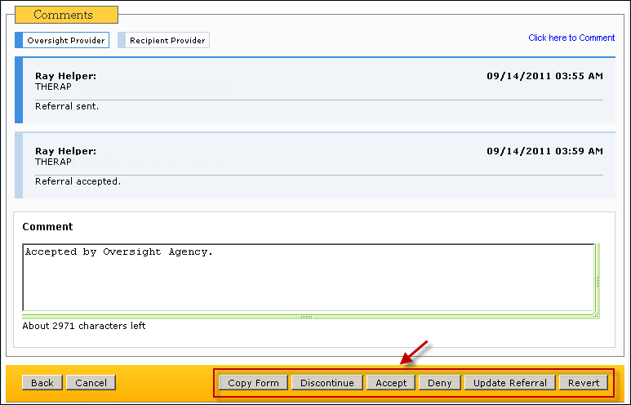

Referral Button definitions:
Save | Click on this button when you are going to work further on this Referral packet before you are ready to send this. The Referral packet will be saved in your work list.
Send Referral | Click this one to send the Referral packet to the Provider(s)
Send Referral and Continue | When you want to send the packet to more than one Provider, click this button. It will send the packet to the selected Provider and give you a copy of the same form with all the attachments so that you can select the next provider and send the Referral.
Copy Form | This lets you copy the Referral form along with the attachments so that the same packet can be sent to another Provider.
Delete | In case you have created a Referral packet by mistake, you can Delete it while it is in 'In Prep' status.
Discontinue | You can terminate the Referral process using the Discontinue button.
Update Referral | You can add a comment or additional attachments to a Referral packet and then click on the 'Update Referral' button. This will generate an 'Acknowledge' count for the Provider.
Accept | Use this button to Accept the Referral as the DDPM/Oversight. This can happen only after Provider has accepted the Referral.
Deny | Use this button to Deny the Referral as the DDPM/Oversight. This can happen only after Provider has accepted the Referral.
Revert | Using the 'Revert' button, the DDPM can take the Referral packet back to immediate previous status. (e.g. From 'Accepted by Provider' to 'Pending Provider Response')
Close | Use this button to finally Close the Referral. Before you can close the Referral, State Office needs to copy the Oversight ID into the Provider's account.

Regional Dashboard for Referral

Regional Dashboard for Referral provides Detailed Referral Reports of Individuals of a particular region to Oversight Agency users assigned to that Region.
In order to access the Referral Report, Oversight Agency users will need to be assigned with the Referral Report Role. Referral Report Role is an agency wide Role.
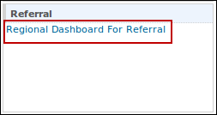
Only the DDPA and the DDPM III type users will be able to access the Referral Report. If any user who is not a DDPA or DDPM III, is assigned with the Referral Report Role, the user will be able to view the Regional Dashboard for Referral link, but will not be able to access the report.
Clicking on the Regional Dashboard for Referral link will open the Regional Dashboard for Referral page.
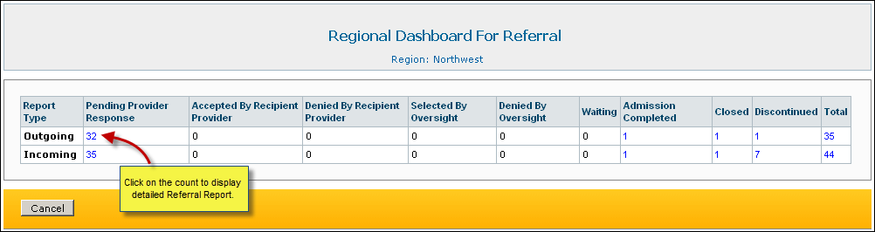

Question and answers:

Q: If my client leaves services from Provider A and then returns, should the referral be created (since it truly is a new referral for services)?

A: Yes, items within the person’s plan may have changed and there should be a referral sent on their behalf. HOWEVER, if they have only left due to a hospitalization and such, then they will be ISP’d out of services, but once they are getting out and are able to move back home, a new referral packet will not have to be sent for situations like (or similar) to this.

Q: I have sent out a statewide referral and nobody can take this person. What do I do?

A: The DDPM from the referring region will contact Keith Vavrovsky at the Developmental Center and in his absence, Sue Foerster or Paul Kolstoe regarding the referral that has been created and needs their attention. They will review the information and get back to you/respond via Therap.

Q: How do we manage these state wide referrals at the regional level, particularly when providers are accepting people from other regions as a result of the statewide referral process?

Scenario:
Case in point is that Jim had completed a statewide referral on client A. Client A is currently residing at the NDSH and the hospital is pushing for placement. Before she can transfer to the NDCC, all community options must be exhausted. A provider got the referral and jumped on it for the SMI group home that they say is going to start on June 1. (As you know, there is concern about this program in the first place). The provider called requesting information right away on client A. Jim got concerned because he thought he was supposed to be doing something but hadn’t had any contact with DD Program Management in Fargo. He finally got in touch with Wanda, but they are used to working with DDPMs rather than directly with providers. In another instance one of the Region VII providers accepted a client from another region and made plans for placement prior to the local regional DDPM becoming involved.

Answer:
When the sending region is contacted by a provider regarding interest in serving the referred individual, the assigned DDPM will contact the receiving region’s DDPA to consider assignment of a local DDPM to be included in the planning process. Agreement must be made between all team members that the individual can be adequately served in the proposed environment. This includes input from the sending region, receiving region, legal decision maker, and provider.

The DDPM staff in the receiving region needs to be involved right away so that they can review and schedule a meeting to review the person’s risk assessment, service options/requests and have an idea of whether or not the person’s needs can actually be met in that region by that provider.

Q: Is it possible for a DDPM to retrieve an initial statewide referral that has been sent (with the attachments) and attach a new document to the initial referral info and send it as a second statewide referral? Or, does the DDPM have to create a new referral packet and attach the new information?

Scenario: The DDPM sent out a statewide referral. A provider responded and asked for more information. The DDPM got the information requested and scanned it in. The DDPM is wondering if he can retrieve the initial referral packet with all of the attachments and then attach the new scanned document and send a statewide referral so that the provider that requested the new info and all other providers get the updated info.

A: Yes – when a provider asks for more information via the referral process, anything that you scan in can be attached to the referral packet for THAT provider, not for everyone (did everyone ask for it or only that one). They cannot add it to the statewide referral packets that were initially sent out, this is done per provider at this point. SO, have ALL your information available and scanned in at the initial packet and you will alleviate having to add additional information for future packets.

Q: I have a provider who says that they cannot see the person on their caseload.

A: The DDPM must contact the State DD Therap help desk to assure that the client has actually been linked to that provider and we have oversight privileges. Once you know that they are in fact linked, but the PC STILL can’t see it, they need to check with their Provider data administrator who may NOT have assigned the case to the PC at that facility.

